Pennar Community
School

HANDBOOK FOR
PARENTS

Mr D M McGarvie
September 2016

Pennar Community School

Owen Street Cross Park
Pennar Pennar
Pembroke Dock Pembroke Dock
Pembrokeshire Pembrokeshire
SA72 6SL SA72 6SW
Tel No: 01646 684402 Tel No: 01646 683839
Fax No: 01646 685056

Email: head.pennar@pembrokeshire.gov.uk
Web page: www.pennarcommunityschool.co.uk
Follow us on Facebook

The academic year 2016/17

A school has been situated in Pennar for over 125 years, ever since Pennar Girls Board School was first opened in January 1874. The education of children on the Cross Park site and Owen Street site continues this fine tradition of education in this area.

Since the merger of the separate Infant and Junior schools in September 2006 there has been a steady movement of children up to the Owen Street site, as the building there has benefited from 2 new builds, resulting in five new classrooms. Nursery to Year 6 are educated here.

Flying Start Playgroup is based at the Cross Park site.

Flying Start, a provision for 2 – 3 year old child care is well established. Children are admitted the term after their 2nd birthday for up to five sessions of 2 hours 30 mins. This facility is free of charge. This facility is only available for people who live in the Pembroke or Pembroke Dock area at the moment.

We provide full time education for children the term after their 3rd birthday. These children attend Part Time Nursery 9.00-11.30am stay for packed lunch 11.30-12.30 and then attend Tiny Tots 12.30pm – 3.00pm or vice versa, Part Time Nursery afternoon and Tiny Tots morning.

The school experienced a full ESTYN Inspection in February 2014. The findings can be seen in this handbook or a more comprehensive report is available from the Head Teacher or it can be viewed on line on the Estyn website. The report makes very positive reading and reflects the hard work of the pupils, staff, governors and parents in making Pennar School what it is.

I had the pleasure of starting my teaching career at Pennar School 17 years ago, spending 12 years working with the children and their families. I am delighted to have returned as Headteacher, it was a very proud moment for me when I was appointed. I am looking forward to working with the pupils, parents staff and governors to ensure the continued success of Pennar Community School and further enhance its proud standing in the community.

Your child could be in our school for 8 years and I look forward to working with you to ensure the best possible education for your child. I also look forward to meeting you on many occasions over the coming years. I am pleased to have such a pleasant and hardworking staff. The staff take great care in planning and organising their lessons and in their delivery, so that the children are well motivated and enjoy their school experience. Three of our teachers have been recognized for their excellent professional practice by being seconded by the L.A.

We expect high standards of behaviour and demand the children show respect for their peers, staff, visitors and property of the school.
New parents have commented positively on the warm welcome and atmosphere in our school and are pleased with the way their children settle into school life at Pennar.
I look forward to meeting new parents and their children this year.
Damon McGarvie (Headteacher)

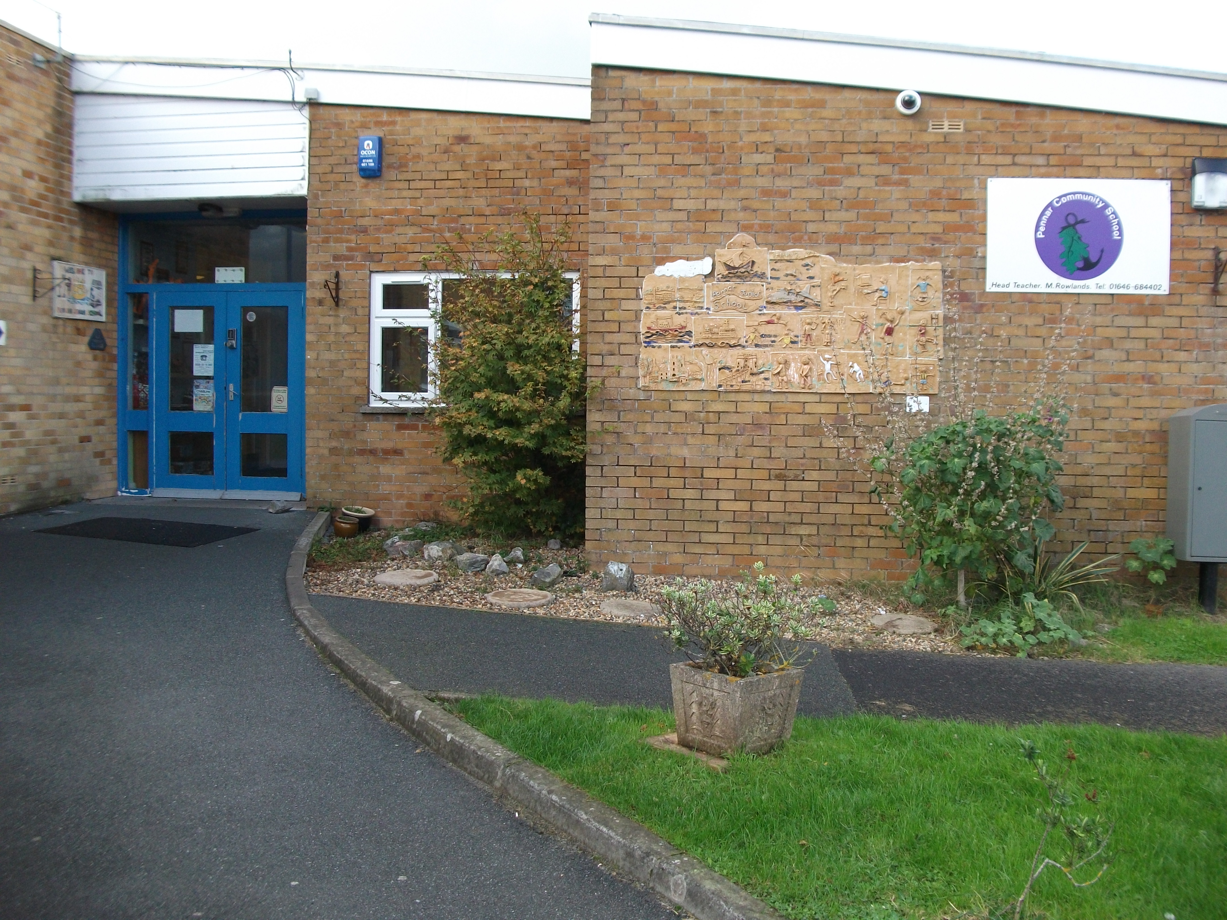

This is our Owen Street site
for Nursery to Year 6.

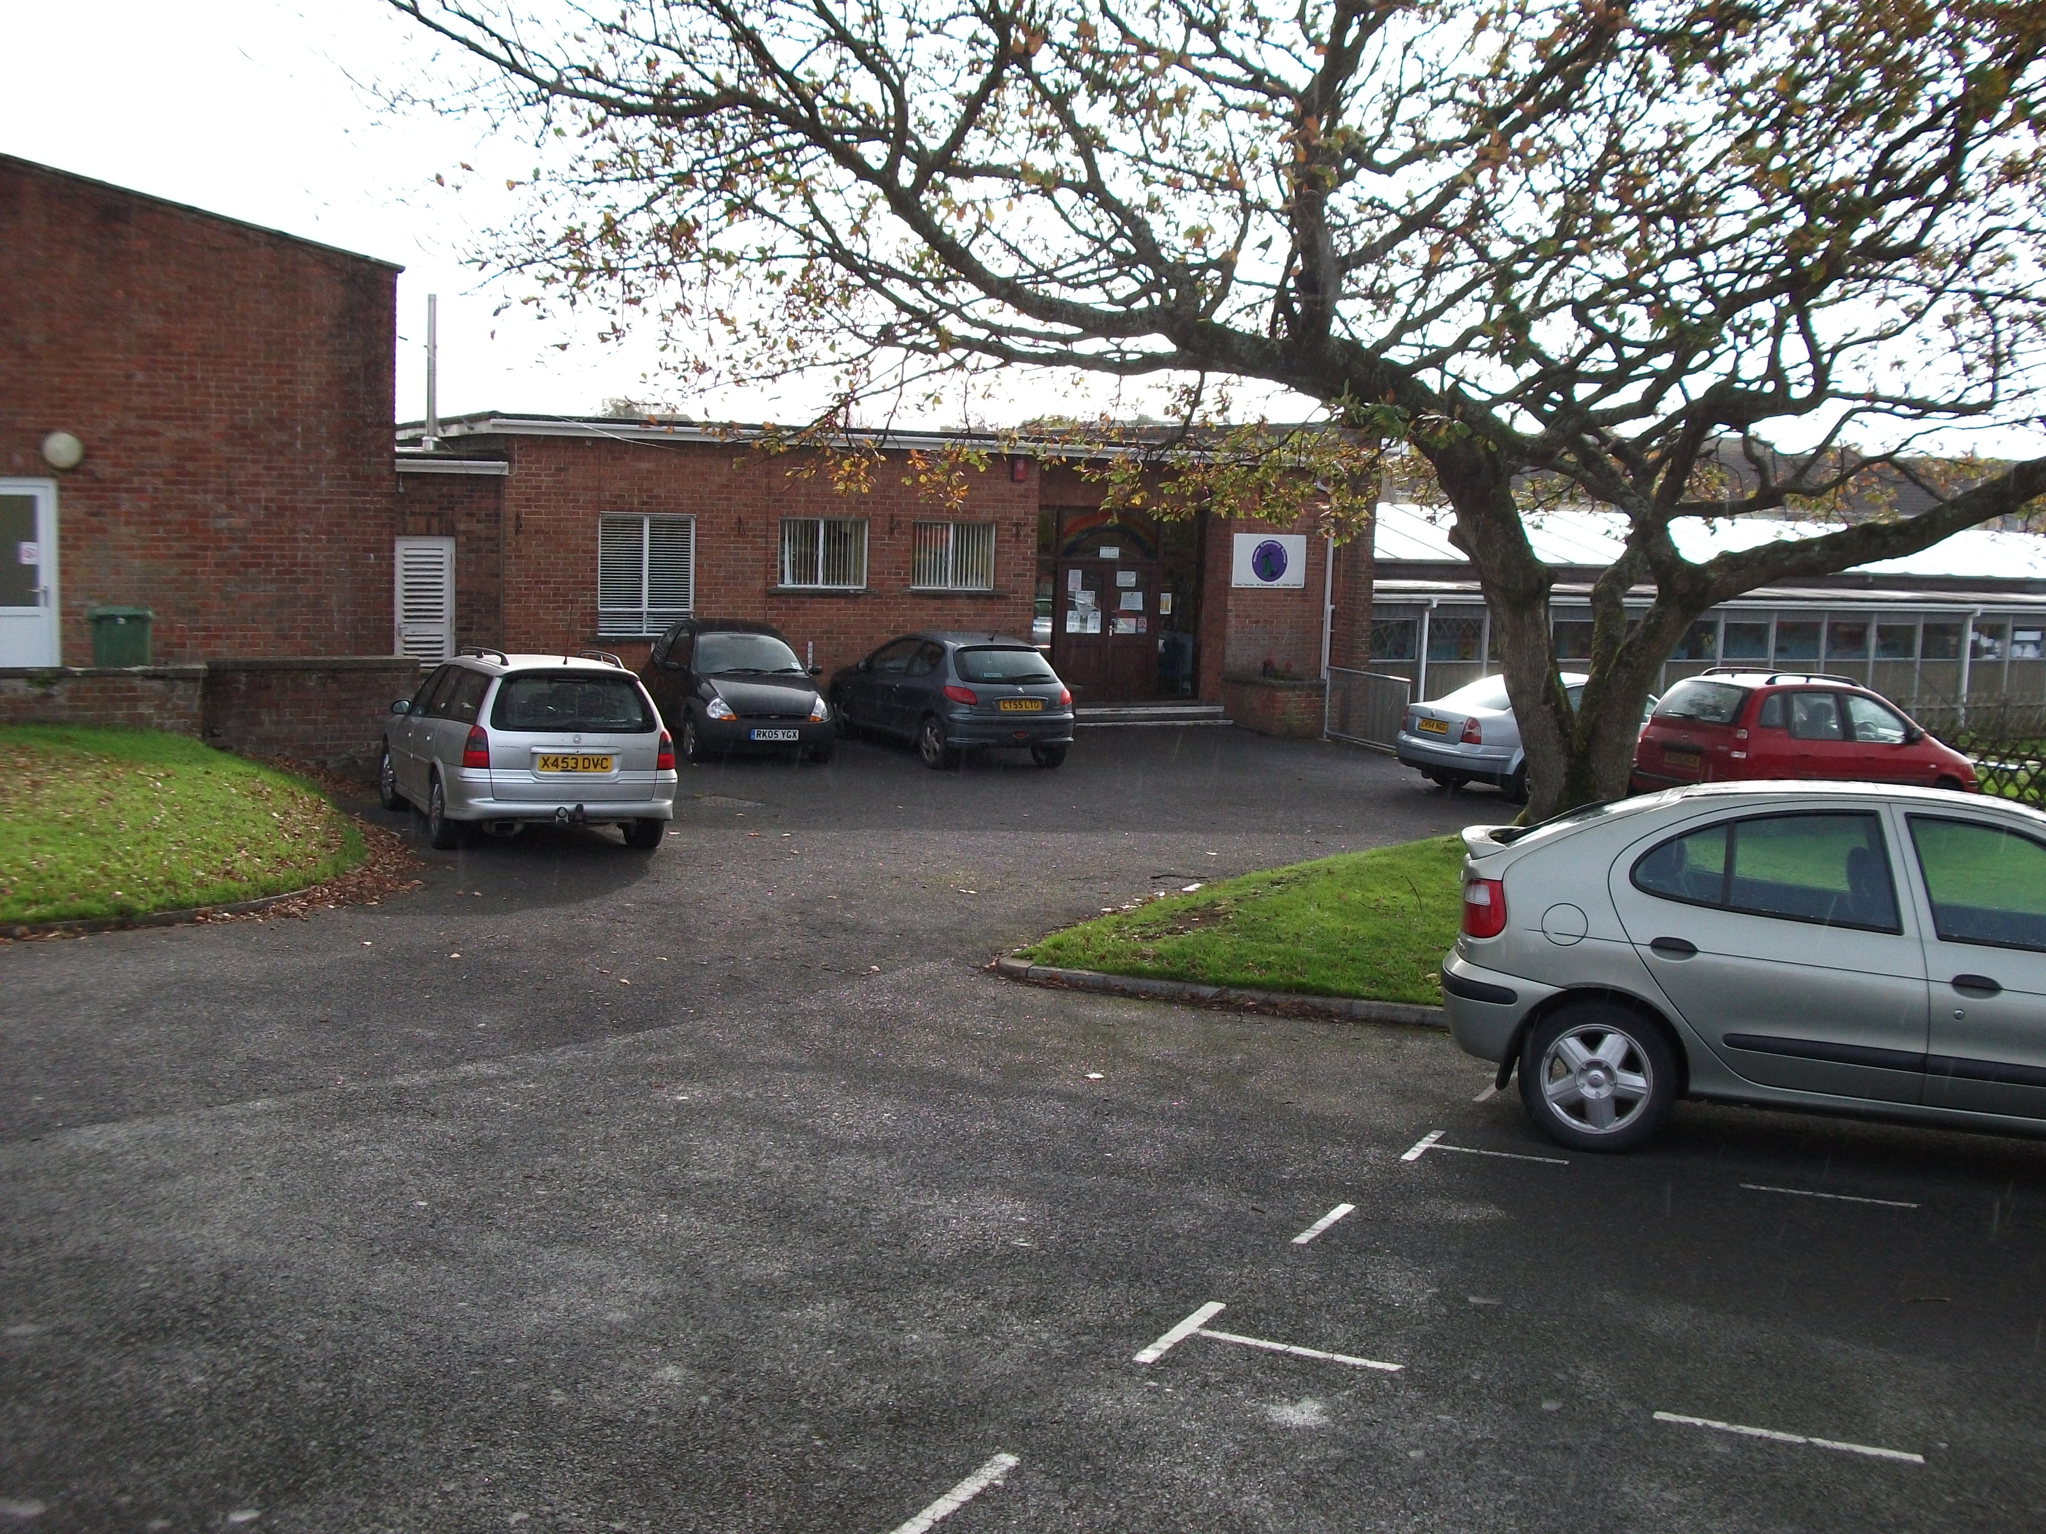
This is our Cross Park site for Flying Start
Playgroup.

CONTENTS Page
Admission ………………………………………………………………………………………………………………. 9
Additional Learning Needs ………………………………………………………………………………….. 24
After School Clubs ……………………………………………………………………………………………….. 10
Aims and Mission Statement…………………………………………………………………………………. 6
Accidents and illnesses ……………………………………………………………………………………….. 14&15
Attendance and Punctuality ………………………………………………………………………………. 13
Background ……………………………………………………………………………………………………………. 8
Breakfast Club ………………………………………………………………………………………………………. 13
Bullying ………………………………………………………………………………………………………………….. 28
Charging Policy …………………………………………………………………………………………………….. 18
Cheque payments …………………………………………………………………………………………………. 19
Child Protection …………………………………………………………………………………………………… 29
Contact with the School ……………………………………………………………………………………… 17
Collective Worship ………………………………………………………………………………………………. 25
Complaints about the Curriculum ……………………………………………………………………… 18
Curriculum ……………………………………………………………………………………………………………….. 21
Debt recovery …………………………………………………………………………………………………………. 19
Discipline ……………………………………………………………………………………………………………….. 27
Dinner Money …………………………………………………………………………………………………………. 19
Equal Opportunities …………………………………………………………………………………………….. 11
Ethos ……………………………………………………………………………………………………………………….. 11
Facebook ………………………………………………………………………………………………………………… 14
Family Liaison Officer ………………………………………………………………………………………….. 14
Fire Drills ………………………………………………………………………………………………………………. 11
Foundation Phase …………………………………………………………………………………………………… 21
General Information …………………………………………………………………………………………….. 12
Governors ……………………………………………………………………………………………………………….. 21
Healthy Schools …………………………………………………………………………………………………….. 23
Houses ……………………………………………………………………………………………………………………… 27
Lettings …………………………………………………………………………………………………………………… 19
Lost property …………………………………………………………………………………………………………. 18
PTA ……………………………………………………………………………………………………………………………. 14
Pastoral Care ………………………………………………………………………………………………………….. 16
Personal items ………………………………………………………………………………………………………… 26
P.E. and Games ……………………………………………………………………………………………………….. 24
Restorative Practice …………………………………………………………………………………………….. 28
School meals ……………………………………………………………………………………………………………. 13
School Uniform/Clothing …………………………………………………………………………………….. 25
School Visits ………………………………………………………………………………………………………….. 26
Security ………………………………………………………………………………………………………………….. 27
SRE…………………………………………………………………………………………………………………………… 25
Staffing Structure ……………………………………………………………………………………………… 19
Sustainable Schools ……………………………………………………………………………………………… 23
Times of Sessions …………………………………………………………………………………………………. 12
Transfer to Secondary School …………………………………………………………………………… 29
Truancy Call ……………………………………………………………………………………………………………. 14
MISSION STATEMENT

The School aims:

1: To educate pupils intellectually, socially, morally, aesthetically, physically, emotionally and spiritually.

2: To look after the mental and emotional wellbeing of the pupils and staff.

3: To enable pupils to grow in each of these areas and achieve fullness of life through discovering and development of their talents and by putting before them positive and realistic goals.

4: To promote positive values within the school and to encourage in pupils a sense of decency, commitment, self-reliance, responsibility, respect for others and a healthy self esteem.

5: To help pupils find a true vocation in life; to prepare them for the world of work and life in the community beyond school; to encourage everyone to be a rounded person capable in making a positive contribution to the society and environment in which he/she is to live, move and have his/her being.

6: To help pupils to take responsibility for the care of their environment and instill in them that through their positive actions changes can take place.

To stimulate in the child a sense of curiosity and excitement about the world and to encourage him/her to search for the truth, meaning and purpose in life; to provide an opportunity to search for a faith by which to live.

Our pupils have chosen the school motto : We Believe - We Achieve - We Succeed

AIMS - EDUCATIONAL

- To develop lively, inquiring minds, encouraging the ability to question and discuss rationally, and apply themselves to learning tasks and developing skills.

- To enable each child to develop an understanding of moral values and an awareness of the needs of others through a knowledge of Christianity and other religions.

- To help pupils acquire knowledge and skills relevant to adult life and employment in a fast changing world.

- To educate pupils to make healthy choices, regarding exercise and diet.

- To help pupils use language and numbers effectively.

- To help pupils understand the world in which we live and the interdependence of individuals, groups and nations.

- To develop the child as an individual and their understanding of all the aspects of the Curriculum.

- To help pupils appreciate human achievements and aspirations.

AIMS - GENERAL

- To develop the skills, experiences, knowledge and imagination so that each child will be aware of good everyday values.
- To develop positive attitudes towards, and concern for, the environment and to one another.
- Maintain good discipline and order within the classroom and throughout the school.
- To develop in pupils a positive attitude towards themselves and others, with a strong sense of self respect, and develop a sense of respect for other people’s property, ideas and beliefs.
- To appreciate human achievement, aspirations and failures.
- Encourage good manners and thought for others.
- Ensure a safe, happy environment where children want to work and want to take part in activities without fear or favour.
- To offer every pupil an equal opportunity.

BACKGROUND

The Owen Street School was built in 1970, replacing the old school on Treowen Road. The new school is situated on two sites and serves the
community of Pennar, which, although part of the town of Pembroke Dock, has a distinctive character of its own.

Prior to 2004, the Owen Street section consisted of six large classrooms, with a smaller room at the back of the stage, which has been extended to include an I.T Suite. The rooms radiate off a large hall which is used for morning assembly, physical education, music, drama and regular lessons, as well as a dining hall.
At break times and lunchtime children have two main play areas – a large open playground and a smaller sheltered patio, both opening on to a field, which is available when the weather is suitable.

Within the last six years staff toilets and children’s toilets in the older block have been completely refurbished, as have the staffroom and the reception area.
A new extension to the school was completed in November 2004. We now have 3 superb modern classrooms and 3 smaller rooms used to promote accelerated numeracy and literacy and for use by an increasing number of outside agencies visiting the school e.g. speech and language therapists, peripatetic music etc. Further improvements in the provision of a new reference library were also completed in September 2005.

The Cross Park site was built in 1955/56 and was officially opened in 1956. There are three classrooms in the main building , plus two rooms that are used as offices for the Flying Start project.
There is also a recently built Early Years unit. The early years unit consists of two classrooms, toilets for both boys and girls, disabled toilet and shower room.

The large hall in the main building is used for assembly, concerts, music, drama, physical education, cookery as well as a dining hall. A library has been established in the hall.

There is a playground which is bordered by large areas of grass where the children can take part in the Outdoor curriculum.
A new play area for Flying Start was constructed in 2008, with a log train and a play cabin.

Canopies have been installed on both sites to facilitate the new curriculum.

ADMISSION

The school caters for children aged 2 to 11 years.
Flying Start
Children can enter the Flying Start Playgroup in the term after their second birthday.
They may attend up to a maximum of 5 mornings or 5 afternoons.
Nursery
Nursery children are admitted on a part-time basis in the term after their third birthday.
Children can also move to Tiny Tots playgroup the term after they are three.
We operate a wrap a round system which means that, if you wish, your child can attend Nursery and Playgroup and stay for lunch (packed lunches).
They could be in school from 9.00am – 3.00pm.
The children are introduced to the first stages of learning through play, social interaction , developing skills etc.

Separate brochures are available for parents of children entering Flying Start Playgroup and Tiny Tots Play group.
A leaflet about your child entering full time education is sent out in Reception class.

If you are thinking of applying for a place at the school please contact Mr McGarvie, Headteacher, on 01646 684402.

Parents can now send their children to the school of their preferred choice regardless of where they live. This is however dependent on parents taking responsibility to transport their children to and from school. We currently have places available in most but not all classes in the school.

AFTER SCHOOL CLUBS
3:15 pm to 4:00 pm

 | Autumn | Spring | Summer
Monday | Eco Club  Reading Club | Eco Club  Reading Club | Eco Club  Reading Club
Tuesday | Pyramid (Foundation Phase)  Food Co-op  PE Club  Mathletics  Judo | Pyramid (Foundation Phase)  Food Co-op  PE Club  Mathletics  Judo | Pyramid (Foundation Phase)  Food Co-op  PE Club  Mathletics  Judo
Wednesday | STAFF MEETING
Thursday | 8:30 Reading Club  Netball Club  Buzz Club  Homework  Art Club  Rugby | 8:30 Reading Club  Netball Club  Buzz Club  Homework Club  Art Club  Rugby | 8:30 Reading Club  Athletics  Rounders/Cricket  Samba Club  Buzz Club  Homework Club  Art Club

We play sporting fixtures at both under 11’s and under 9’s – A and B level. The emphasis will be on participation by all pupils who show interest and not by ability.

EQUAL OPPORTUNITIES

We operate an equal opportunities Policy in the school. This is constantly reviewed and updated and is available for parents to read if they so wish.

ETHOS

We aim to help all pupils achieve in a safe, happy, caring and stimulating learning environment.
We aim to:
- Enable each pupil to have a happy time at school whilst working to their full potential.
Home/school agreements are designed to help children develop in supportive surroundings both at school and at home so that the child can make the most of opportunities available during his/her time in school. These home/school agreements are sent out to parents immediately after their child begins school life at Pennar.

FIRE DRILLS
These are held termly at different times of the day, so that all staff and pupils are familiar with the procedures.

GENERAL INFORMATION

School session times

CROSS PARK SITE
Flying Start

9.00am -11.30am – Morning session
12.30pm – 3.00pm – Afternoon session.

Owen Street Site

Nursery and Tiny Tots Playgroup 9.00am – 11.30am – morning session
12.30pm – 3.00pm – afternoon session

Please do not try to bring the children in to these classes before the start times as staff will not be present to supervise pupils.

Foundation Phase 8.55am – 12.05pm
1.05pm – 3.10pm

Key stage 2 8.55am – 12.35pm
1.30pm – 3.10pm

Children should not arrive earlier than 15 minutes before the start of the session. Teachers are planning and resourcing the lessons for the day before this time. The school cannot take responsibility for children who arrive before that time.

Key stage 2 pupils will remain on the yard during fine weather but allowed in when wet.

Breakfast Club

The Welsh Assembly FREE breakfast initiative commences as follows:

Monday to Friday from 7:45 am to 8:45 am. Breakfast is served from 8:00 am to 8:30 am. No children are admitted after 8:35 p.m. Nursery and Playgroup children are escorted to their classrooms at the end of Breakfast Club.

SCHOOL DINNERS

School dinners are prepared and served on the premises. All children from Reception upwards are able to purchase a school dinner. You may be entitled to Free School Meals if you receive certain benefits. Please make enquiries at the school office for advice where application forms are available.
Lunchboxes. Packed lunch boxes should be clearly marked with child’s name. We are a healthy eating school so we ask that parents prepare a healthy packed lunch, e.g. no sweets. Cans or fizzy drinks are not allowed.

ATTENDANCE AND PUNCTUALITY

Attendance is compulsory, the term after a child is 5 years old. It is now a legal requirement that all absences are:

- Notified by telephone in the first instance
- Confirmed in writing by parents or guardians
- Recorded in the child’s records

We would appreciate you contact the school to inform of absences at the onset in order that we know where pupils are.
Attendance is now transferred to the clerk’s central computer and provides the Head teacher with comprehensive information about attendance.
We will do our best to undertake a first day response and contact you if there is no explanation forthcoming about an absence. The reasoning behind this is to prevent a child being truant when his parent thinks that he/she is in school and the school may assume that he/she is ill at home. We rely on parents to ensure that children are only absent for genuine reasons.
Parents are reminded that punctuality is a good quality to have and pupils should be encouraged to arrive in school at the correct times.

FAMILY LIAISON OFFICER

Mrs. S Jones has been appointed Family Liaison Officer as from 1st September, 2012. She is available every school day between 8:30 a.m. and 4:00 p.m. One of her main roles is to monitor pupil absence and late arrival. Parents are asked to contact the school on 01646 684402 as soon as possible
in the morning to register their child/children absent through illness or other reason.

PTA – FRIENDS OF PENNAR SCHOOL

A PTA was formed in September, 2013. A number of parents are already organising fundraising and charity events. If you would like to join our PTA please see Mrs J. Hinds our Deputy Headteacher for more information.

FACEBOOK

You can follow events and school news on Facebook, just search for Pennar Community School. Please note that this is an information page and should not be used to contact the school.

TRUANCY CALL

We continue to use an electronic absence line registration system which automatically contacts parents whose child is absent, with no reason, via texts to mobile phone or automated message to landlines.

ACCIDENTS AND ILLNESS

Accidents do happen from time to time, even with the best supervision and children are sometimes taken ill in school.
The school asks that each child should be provided with the name and address and telephone number of a responsible adult in case of emergency (2 numbers if possible). Will you please inform the school as soon as possible if there is a change in these contact addresses.

Children are sometimes sent to school:
- before they are completely well after illness
- knowingly under the weather

This is unfair to both the child and the teacher and often leads to complications.
Health and safety regulations do not allow untrained teachers to administer medication to pupils.
However Mr. McGarvie and Senior management have received training and will administer mild medication provided a written request is delivered to the school and a form completed.
Precise instructions for use should be enclosed together with the card provided by the G.P.

All medication is kept securely locked in a medical cabinet in head teacher’s office. Below are suggested times for keeping children off school after certain illnesses.

Exclusion periods

DISEASE | EXCLUSION PERIOD
Chicken Pox | For 5 days after rash appears
Conjunctivitis | None
Diarrhoea and vomiting | Until 48 hours after the last episode of diarrhoea or vomiting
Hand, foot and mouth disease | None
Hepatitis A | Exclude young children for 7 days after onset of jaundice.  There is no need to exclude older children with good hygiene
Impetigo | Until lesions are crusted or healed
Measles | For 5 days after rash appears
Mumps | For 5 days after the onset of swollen glands
Ringworm | Until treatment is started
Rubella (German measles) | For 5 days after the onset of rash
Scabies | Until treated
Scarlet fever | For 5 days after commencement of antibiotics
Threadworms | None
Tuberculosis | CCDC will advise on necessary action
Whooping cough | For 5 days after commencement of antibiotics

If your child has a specialised medical need a careplan will be put into operation in conjunction with the school nurse, G.P. and parents.
The school has an appointed person responsible for FIRST AID, Mrs.. J. Baker. She is the first point of contact for serious illnesses and accidents on the premises. Most staff members have been trained either in Emergency First Aid or to First Aid at Work level so there is good coverage throughout the school at all times.

Plasters will be used as a means of treatment, if you do not wish your child to have plasters, please make the school aware so that these details can be added to the medical details.

In the event of a child receiving an injury from the neck up, parents will be contacted and asked to decide if they would like to take their child for professional medical treatment. If parents decline this offer, the school may still seek professional advice if they are concerned. In all cases these phone calls will be logged and a coy kept in the pupil’s personal folder.

Pastoral Care
The Headteacher has overall responsibility for the running of the school and works closely with the Deputy Head teacher and the other members of staff.
It is important that the school receives and has up to date records of pupil’s addresses and parent’s home and work telephone numbers, together with details of persons nominated by the parents who can be contacted in the event of an accident or illness.
Should an accident occur during school time which necessitates medical treatment, every effort will be made to trace parents or their nominee. Failing this pupils requiring treatment would either be seen by a doctor at school or conveyed by members of staff to the Out Patients Department of a local hospital by ambulance. Two members of staff will always accompany pupils to hospital.

Minor accidents are dealt with by the duty teacher and the nature of the accident recorded. All members of staff have received emergency first aid training. Designated teachers have received the full First Aiders at work qualification.
Children are supervised for 10 minutes before the commencement of school on the Owen Street site.

CONTACT WITH THE SCHOOL

Parent’s evenings are held twice a year in the Autumn and the Spring. Here you will be able to discuss progress and your child’s development with the class teacher. A written report on your child’s progress is sent out in the Summer term together with an invitation to discuss the report with the class teacher if you so wish.
A new initiative this year will be the sending home of a mid-year target report for pupils in Reception to Year 6. This will detail the steps necessary for your child to continue to make progress in core subjects. This will be available before the Spring parent evenings so can be discussed with the class teacher at that time.

It is important to note that we are available at any convenient time to discuss problems which may arise, but please in the first instance contact the head teacher before the class teacher, especially if the problem is of a serious nature.
If you are at all worried, please come into the school and let us share the problem. Children will not make progress if they are unhappy or anxious. We would like to address any problems at the earliest opportunity and not give it time to “fester”. Problems cannot be solved in the playground or outside the school gates with discussions amongst parents!
A wide variety of documents relating to school and Governors are available for inspection at convenient times.
If you have any concerns, please contact the Head teacher. Our staff can be vulnerable at the end of the day dismissing children directly to you.
If there is any complaint, please see the Head Teacher or Deputy Head teacher.
The school has a zero tolerance to any abuse aimed at our staff and any difficulties should be dealt with in a calm and courteous manner.
Failure to comply with this request could lead to a ban from our premises.

The Email address and the web page address are on the first page of this brochure.

COMPLAINTS ABOUT THE CURRICULUM

These can be made to the Director of Education whose address is:
Kate Evan Hughes, Chief education Officer,
County Hall, Haverfordwest, Pembrokeshire, SA61 1TP.
Tel. 01437 764551

Other complaints or concerns can be made direct to the Headteacher or governing body.

LOST PROPERTY

This is a problem. Clothes, jackets, coats etc. are expensive. Most lost property is never claimed and we are unable to return it to its rightful owner.
Please label you child’s clothes clearly with his/her name and this will help us tremendously in terms of returning property.

Charging policy

Educational trips usually involve no charge, although we may ask for a voluntary contribution to such places as Skomer and the Torch Theatre. All such trips are subsidised by about 25%. No child from Pennar School will ever be excluded from a school trip if their parents do not make a voluntary contribution. The only exception to this could be our annual visits to Llangrannog and Sealyham.
Music lessons are free but we charge a nominal sum for the hire of instruments bought by the school. The rental encourages commitment and is used to purchase new instruments.
Cheque payments

Dinner money cheques should be made payable to “Pembrokeshire County Council”. Cheques for voluntary donations for school visits should also be made payable to Pembrokeshire County Council.

Dinner money

Dinner money should be paid on a Monday for the week if possible.
Money should be placed in the envelopes provided and clearly marked with the child’s name, class and amount to be paid.
Parents are notified if there is any change to the cost of a school meal.
Your child may be eligible for free school meals please ask the clerical assistant for details or forms.

Lettings

The school is available for use by community groups. A Lettings Policy has been agreed by the Governing Body and is available from school if anybody is interested in using the school as a venue for their organization.

Debt Recovery

The school operates a debt recovery policy in respect of monies payable for services and or lettings. Where possible the school will work with parents and organisations to make any payments as easy as possible.

STAFF ORGANISATION

Staffing levels are determined by the budget. The governors have agreed to the following teaching staff for the academic year 2012/13
Headteacher | Mr. D McGarvie
Deputy Headteacher | Mrs J Hinds
Teaching staff | Mrs.. C Thomas  Mrs.. S Taylor  Mrs.. A Gilbert  Mrs.. S McGarvie  Mrs.. E James  Miss E Knight | Mrs.. J Baker  Mrs.. S Williams  Mrs.. E Evans  Mrs.. Rachel Davies  Miss Kathryn Hawkins  Miss M Picton  Mrs Alison Johns
LSA’s | Mrs. H Allen  Mrs. S Booth  Mrs. E Evans  Mrs. J Burton  Mrs. S Jones (FLO)  Mrs. D Kaijaks  Mrs. A Lewis  Mrs. C Roberts  Mrs. D Russell  Mrs. S Thomas  Miss C Baines  Mrs. V Reynolds  Mrs. T Phillips | Miss G Thomas  Miss M Wallace  Mrs. K Hammond  Miss K Jamieson  FLYING START  Mrs. J Manning  Mrs. J Griffiths  Mrs. S Baines  Mrs. S Roberts  Miss G Thomas
Business Manager  Secretary | Mrs. H Lewis  Mrs. L Asparassa
Caretaker | Mr. K. Claypole
Cleaners | Miss M Thomas  Mrs. M Owens  Mrs. M Harding
Kitchen Staff | Mrs. E John  Mrs. M Owens  Mrs. K Lawrence
Meals Clerical | Mrs. J May
Lunchtime Supervision | Mrs. J May  Mrs. M Harding  Mrs. K Osborne  Mrs. S Polkinghorn  Mrs. L Goodwin  Mrs.. S. Durkin  Miss F Whitfield | Breakfast Club  Mrs. J May  Mrs. M Harding  Miss K Jamieson
School Crossing | Mrs. Miller

Governors

Mrs. A. Newman (Chair)
Cllr Mrs. M. Colgan (Vice Chair)
Rev R Hart
Mr. D McGarvie (Headteacher)
Cllr A McNaughton (Community)
Mrs. P Folland (Community)
Mr. A Wilcox (Local Authority)
Mrs. S Jones (Staff)
Mrs. E Evans (Teacher)
Mrs J Hinds (In attendance)
Mrs. S Thomas (Parent)
Mrs R Broughton (Parent)
Rev L. Squires

All correspondence should be addressed to the governors via
Kate Evan Hughes, Chief education Officer, County Hall, Haverfordwest, Pembrokeshire, SA61 1TP. Tel: 01437 764551

CURRICULUM

Nursery, Reception, Year 1 & 2 (3-7 years)
The Foundation Phase Curriculum.
This places emphasis on independent learning, incorporating subjects cross curricula with a focus on Personal and social development..
The areas of learning are:
Personal and Social Development – Well being Cultural Diversity
Language, Literacy & Communication
Mathematical development
Knowledge and understanding
Physical development
Welsh Language Development
Creative development
Together with R.E and I.T

The curriculum emphasis is on acquiring skills and not just the acquisition of knowledge.

Children learn through carefully planned activities that are in the main practical. Children are taught to work independently from a very young age, many of the activities are suitable for working both indoors and outdoors.

Children also follow a structured Literacy programme, “Read, Write Inc!”.
At the end of Year 2 children are assessed within the school and an outcome is given in:-

- Language, Literacy & Communication
- Mathematical Development
- Personal and Social Development – Well Being and Cultural Diversity

The aggregate results for each school is published by the Authority.

Key Stage 2

In Key Stage 2 we have recently embarked on a new skills based curriculum.
As a school we have decided to continue a themed based approach which we cover over a 2 year cycle. Wherever possible we try to work in a cross curricular way, but that does not exclude discreet teaching when deemed more efficient or practical.

The areas of the curriculum are:
Personal and Social Education.
Mathematics
Language and Literacy.
Welsh
Science
Geography
History
P.E.
Music
Design and technology
P.S.E.
Religious education.
I.C.T.
Children are formally assessed at the end of Key Stage 2 and a level is given. Results are published by the Local Education Authority.

Healthy Schools
Pennar School prides itself on being a Health Promoting school. We are part of the Health Promoting Schools initiative and are currently working towards the national Quality award.
The areas we work on are:
Food
Exercise
Safety
Substance Abuse
Relationships
Environment
Hygiene
We feel that this is an intrinsic part of a child’s education.

Sustainable Schools
We have recently gained the bronze award for sustainable schools and are now working towards the silver award. Working on topics such as:
Water
Community
Global Citizenship
Biodiversity
Waste & Litter
Energy
Transport
Healthy Living
Healthy Eating policy
SRE provision

Additional Learning Needs
We endeavour to cater for every child who wants to attend Pennar School and can make arrangements for changes to be made to the physical environment if it is needed. Mrs. A Gilbert, ALNCO has non-contact time on Thursdays and would be prepared to meet with any parent for discussion, if an appointment is made beforehand.

Children with additional learning needs
Some children may need help to enable them to make progress.
Help and advice is given by the School’s own Additional Needs Coordinator, but sometimes more specialised advice must be sought from educational or medical sources. Before taking this step however, parents will be consulted and their permission sought.

Additional Learning Policy

This policy is available for all parents to view if they so wish.

Your child’s needs will be dealt with sympathetically and practically.

Regular reviews are carried out and parents are involved in the production of an Individual education plan for the child in question.
The ALN is well supported by the Head Teacher and staff and we have an excellent team of LSAs with expertise in different areas of Special education.
The Governing body is fully committed to making financial resources available for pupils with ALN on a fair and equal basis.

P.E. and Games

All children are expected to change for P.E and games.
Dabs may be worn but trainers and football boots are only accepted for outdoor games.
Bare feet are preferred for dance and gymnastics.
No jewellery to be worn in P.E and games sessions. This is for Health and safety reasons.
All long hair should be tied back from the face.
T shirts and shorts should be provided and kept in a gym bag.
Please remember the days on which your child has P.E are the same every week and kit should be in school for those days. Children without kit do not partake in P.E.

SRE

In Pennar Community School we believe that sex and relationship education (SRE) is an important issue, which will help pupils to understand physical and emotional changes in the human body.

The school regularly reviews its SRE policy and schemes of work, which have to be approved by the head teacher and governing body.

Under the 1996 Education Act, pupils can be withdrawn by their parents/guardians from the parts of the sex education programme that are outside the compulsory elements of sex education contained in the Science National Curriculum.

Any parent wishing to see the SRE policy or schemes of work for pupils in our school can do so by request, an annual meeting will be offered with the coordinator to share this information.

Collective worship

Collective worship is held daily. We often welcome visitors to our assemblies. On Fridays we have achievement assemblies.
Older pupils are encouraged to contribute to assembly by reading a prayer.
Throughout the year there are occasions on which we invite parents in to school to share our assembly.

We have a very good relationship with clergy in the area and are delighted when they come to take an Assembly, particularly Rev. Hart who visits us on a weekly basis.

School uniform

We strongly recommend that your child wears uniform. This helps to establish a pride in their school and fosters a sense of belonging.
We have a purple sweatshirt and a jade polo shirt. A purple fleece is also available. These can be purchased on either site and prices are available on application. We do not make any profit from the sale of uniform and only charge what our suppliers charge us. Please label all items of uniform. A popular choice is the purple reversible fleece for use in wet weather. Uniform can be purchased through Tees R Us in Pembroke Dock.

Personal items
Pupils are not allowed to bring mobile telephones to school.
Jewellery is not an acceptable part of school uniform and causes unnecessary hazards in school life. We respectfully ask for your cooperation here. Children with pierced ears are asked to wear studs.

School visits

Pembrokeshire County Council are particularly vigorous in the Health and Safety aspects of school visits, for instance we have to ensure staff/pupil ratios for Junior children and Infant children. The ratios depend on the activity & make up of the group. Risk assessments are filled in for every visit.
Classes are taken out of school regularly for a variety of educational purposes. Recent legislation has placed a greater emphasis on the voluntary nature of parental contribution towards the cost of such activities. Without the continued financial support of parents our outside activities will be severely curtailed.
Parents will be kept informed of all extra curricula activities and asked to sign consent forms when the children go outside the immediate locality.
There will also be a blanket consent form for you to sign to allow your child to go on shorter trips e.g. to the local sports centre, church etc.
This consent form will cover such as the above and other regular short trips e.g. walking from one site to the other.

Security

Entry to both sites is through a controlled access. Visitors are asked to sign a visitor’s book.
A risk assessment of the buildings and grounds is carried out annually.
The school gates are closed throughout the school day and only opened at the end of session times for parental access.

Regular fire drills are held and there are fire doors leading from every classroom and the halls.
A strict rule of walking pace is applied for all movement in the buildings.
Road safety patrols are in place at the beginning and end of the school day.
Parents are asked to keep vehicles away from the school gates.

Discipline
High standards of behaviour are expected throughout the school.
We operate a rewards and sanctions policy and all children are aware of what is expected of them
Each class has a set of school rules on the wall.

Incidents of bad behaviour are logged and if it is of a serious nature parents may be asked to come into school to discuss the problem. We certainly appreciate working with parents.
Home/school agreements between parents, pupils and school are signed each year.
Our policy on discipline are available for any parent who wishes it.

Houses

We have introduced a new initiative of sorting the children and staff into “Houses” which will be used as a reward scheme and a sanction in support of the discipline policy. The four Houses chosen by the School Council are : Angle (Yellow) Barafundle (Red) Broad Haven (White) and Freshwater East (Blue). The colours were also chosen by the School Council to represent the colours featured on the Pembrokeshire flag. House points will be awarded throughout the year for good behavior, good work, participation in our Eisteddfod, swimming gala and school sports. A weekly count of points will be made and a cup presented to the winning House at the end of the year. We have tried to sort the pupils into Houses along with other family members, if we have made any glaring errors please feel free to come in and mention to us.

Bullying

Our School Council have come up with this statement : Here at Pennar Community School we think bullying is when someone is repeatedly hurt by being physically or verbally targeted. We think bullying is wrong and we will not accept bullies in our school.

With your support we hope to solve any problems quickly and effectively by vigilant monitoring of children in the classroom, at play and to and from school. We encourage pupils to tell us immediately any unkind action towards them especially continuous harassment.
Bullying will not be tolerated.
Parents will be informed of any instances of bullying and of the sanctions we wish to impose.
However, bullying must be separated from silliness, squabbles and general disagreements among pupils.
If you have a grievance or suspect bullying then LET US KNOW AT ONCE

If you would like to view the anti bullying policy or the discipline policy, they can be found at the following address or by request from the school.
http://www.pembrokeshire.gov.uk/content.asp?Language=&id=11033&nav=647,690&parent_directory_id=646

RESTORATIVE PRACTICE

All staff have been trained in the use of Restorative Practice throughout the school. It is based on the understanding that harm has been done to people and relationships and it creates a recognition of pupils’ obligations and liabilities. It focuses on the repairing of the ‘harm’ and making things ‘right’. A member of staff has been appointed to facilitate Restorative Practice throughout the school day.
Child Protection

At Pennar Community School we take child safety very seriously, a child protection policy has been formulated in accordance with Local Authority Guidelines. This policy has been adopted by the Governing Body and will be adhered to strictly. All staff members have been trained in Child Protection procedures and the importance of confidentiality. We operate on the policy that all concerns will be raised with the Local Authority officer for safeguarding and the Child Care Assessment Team. We operate the policy that we would rather make a referral and find the claims to be false, than to take no action and this to result in harm coming to a child. We are aware that this can sometimes lead to distressing situations for families but we ask you to understand the reasons behind our actions.

Further information Appendix A

Transfer to Secondary school
Children transfer at age eleven+ to Pembroke Comprehensive School in the main. There is an excellent liaison between our school and the comprehensive. We both work hard to ensure a smooth transition for our pupils.

Finally we hope that your child has a wonderful experience during his/her time at Pennar Community School.

APPENDIX A

Child protection - Information for Parents or Carers

Parents/Carers should be aware that schools have a responsibility to ensure the safety and well-being of all pupils.

On 1 September 2006, Section 175 of the Education Act 2002 came into effect. This introduced a duty on local authorities and the governing bodies of maintained schools to have arrangements in place to ensure they safeguard children and that such arrangements have account of guidance issued by the Welsh Government.

Our school has adopted the Local Authority Child protection Policy and Procedures for Schools 2012 which is governed by the All Wales Child Protection procedures 2008. This policy can be viewed at school, on request.

What does this mean for parents/carers in practice?

Where a professional has a concern about a child, they will, if possible, seek to discuss this with the family and seek their agreement to making a referral to Social Services. Sometimes this may not be possible (eg: if it is felt there is increased risk to the child in speaking to the family). Advice on such matters will be provided by the local Social Services Department in consultation, where appropriate, with the Police. The school will always be working in the best interests of the child.

The designated child protection person at the school should clarify with these statutory agencies, when, how and by whom the parents or carers will be told about any referral. They should also seek advice as to whether or not the child should be told of the process.

In the event of a referral being made to Social Services or the Police, the school may then be involved in any child protection enquiry or police investigation in relation to the child’s welfare and educational progress.

The school will try to work with parents/carers regarding the welfare of their child and remain impartial if their child is being or has been referred.
What support if there for parent/carers?

As a parent or carer you may sometimes feel alone, but there is usually somebody you can talk to. Caring for children is not always easy and if you are struggling to cope you may need to ask for help and support to protect your child. Talking to someone can not only make you feel better, it can also help with the problem. You may find it easier to talk to a professional you know like a teacher or a doctor, who should be able to do something to help. Alternatively there are special organizations that are there to help you when you need support.

SNAP Cymru offer advice and support to families
Helpline: 0845 1203730 Mon – Fri 09:30 – 16:30
e-mail: helpline@snapcymru.org

You may find the following helpful:

- Make time to talk and listen to your child
- Familiarise yourself with your child’s friends and routine
- Be sensitive to changes in behaviour
- Teach your child to feel confident to refuse to do anything they feel is wrong
- Be aware of your child’s use of the internet and mobile phone to ensure they do not place themselves at risk.

If you have child protection concerns about the potential safety or welfare of you child or others, it is important that you act on those concerns. If you have concerns, contct the duty officer in the Child Care Assessment Team on 01437 776322/776325 (08708 509 508 out of office hours) there will be someone there who will be able to tell you what you need to do.

POLICE: in an emergency ring 999

What about if your child needs help to have their voice heard?

Children sometimes need the help and support of an advocate to:

- Get something to happen
- Get something to change
- Get something to stop

Tros Gynnal is an independent advocacy agency which is there to help those children and to make sure that they have their rights respected and have their voices heard.

Pembrokeshire Partnership Advocacy: 07548 320 775

Other useful telephone numbers:

NSPCC: 0808 800 5000

Childline: 0800 1111

Domestic Abuse Helpline: 0808 2000 247

