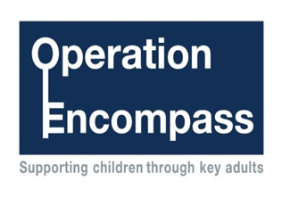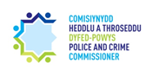

All schools in Pembrokeshire currently take part in a project called Operation Encompass that runs jointly between schools and Dyfed-Powys Police as a county wide initiative.

Operation Encompass is the reporting to schools when a child or young person has exposed to, or involved in, any domestic incident.

Operation Encompass ensures that a member of the school staff, known as a Key Adult, is trained to use the information that has been shared with them about the domestic incident to ensure that a child is adequately supported and/or their families, who have been involved in, or exposed to, a domestic abuse incident.

We are keen to offer the best support possible to all our pupils and we believe this project is extremely beneficial for all those involved.

During the COVID 19 period Operation Encompass will continue to report incidents of domestic abuse period to schools and they may contact you to discuss any support or advice that you might need during this time.

In addition you can also contact someone to talk to through your school’s digital platform/communication channel if you would like to speak to someone further about any concerns or get some advice about domestic abuse.

